Constructing A Prehistoric Cave

Cave drawings gave us a glimpse into the past as to what people were like and how they lived. You are an ancient explorer. You are exploring caves around the area looking for clues into the past. What have you found?
- You are to build a cave that you are exploring. Be sure to include cave drawings and any items that you might discover inside a prehistoric Cave (Tools, Weapons, Wood, Fire, Rocks, etc…)
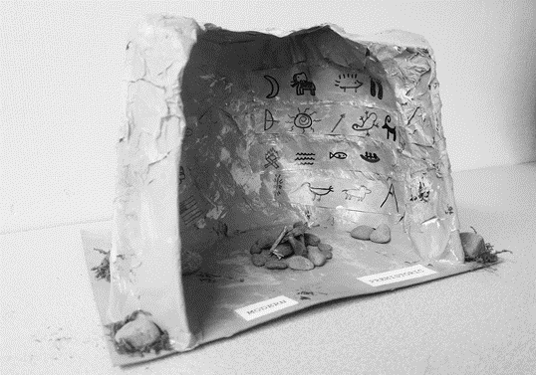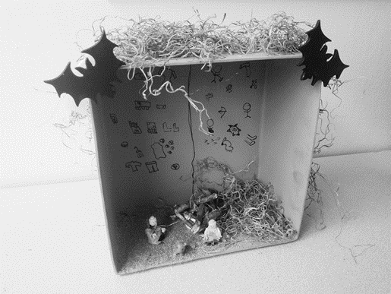

- You can build your cave however you see fit, but for some examples look at the pictures above. The cave on the left is created out of Paper Mache while the cave on the right is created using part of a shoe box. Just some ideas, but be creative as possible.

Grading Rubric:

_____/30 Cave Model accurately depicts life in Prehistoric times

_____/25 Prehistoric Themes and Items are included

_____/25 Neatness

_____/20 Creativity

_______/100 Total Points

Notes:

